Apr 13, 2026

DQ integration in D360 - Phase 1 discussion
Invited Sunetra Virdi Daksha Asrani Ricardo Sobral Ahmet Akkas bbolger@informatica.com Chris Phillips Brian Bolger Chandrika Shankarnarayan Upwan Chachra
Attachments DQ integration in D360 - Phase 1 discussion
Meeting records Transcript

Summary
Stakeholders aligned on Data 360 feasibility while evaluating concurrent headless integration paths via agentic architecture and APIs.
Data 360 Feasibility Analysis
The team established a goal to integrate data quality metrics into Data 360 using native connectors and existing scoring models. This foundational plan aims to enable read-only visibility for analysts while leveraging current IDMC infrastructure.
Headless Integration Strategic Shift
Discussions shifted toward a headless architecture utilizing agent-driven skills to coordinate data quality checks across systems. This model requires moving beyond simple metric display toward active, API-driven task orchestration.
Alignment on Parallel Development
Leadership decided to pursue the headless exploration while maintaining current development plans due to technical uncertainty. Teams will continue monitoring requirements to ensure readiness for emerging agentic workstreams.

Next steps
- [Ricardo Sobral] Get Customer Count: Check the number of customers currently using data quality capabilities for CRM implementations today.
- [Brian Bolger] Schedule Sessions: Arrange 1 or 2 follow up sessions to walk through key differences between CDGC and DI views of data quality.
- [Chandrika Shankarnarayan] Send Skill Definitions: Send skills and cloud definitions proactively to ensure capability assessment.
- [Chandrika Shankarnarayan] Share Information: Pass on all new information regarding headless work requirements.
- [Brian Bolger, Chris Phillips, Ricardo Sobral] Feed Back Status: Reach out to share status and provide feedback on readiness once new headless information is received.

Details
Did the screenshots in this section make your notes better or worse?
- Vision for Data 360 and Initial Plan: The discussion centered on the vision for Data 360, which was presented at a recent PM summit and will be further detailed at the Tech Summit, scheduled for the last week of April. The immediate objective for Data 360 is to begin with a feasibility analysis, acknowledging limited accomplishments in the 264 release cycle. The goal is to align on a plan of action and determine concrete next steps so that meaningful content can be presented at the Tech Summit (00:01:25).
- Upcoming Release Cycle and Introductions: The 264 release cycle is scheduled to begin in June and will run for a quarter (00:01:25). Before deep-diving into the presentation deck, participants including Chris Phillips, Ricardo Sobral, Brian Bolger, Sunetra Virdi, Daksha Asrani, Ahmet Akkas, Upwan Chachra, and Chandrika Shankarnarayan introduced themselves and their areas of focus, primarily within data quality, cataloging, governance, and architecture (00:02:25).
- Data Quality Scope and Strategy: The integration of data quality capabilities within Data 360 will initially focus on structured and semi-structured data, though the long-term vision is to support unstructured data as well (00:06:34). Structured data quality is a well-understood domain, while unstructured data quality requires more definition regarding what "quality" means, how to measure it, and the necessary design and engineering work (00:08:56). Sunetra Virdi noted they were focusing on structured data quality for Data 360, which would begin with the data quality integration (00:06:34).
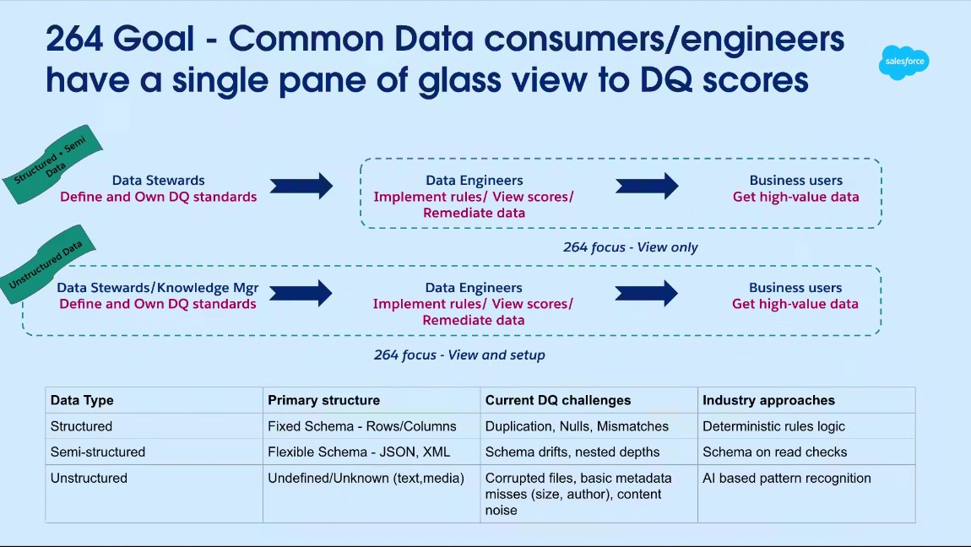
- Initial Data Quality Proposal for Data 360: The base assumption for the initial data quality integration is that overlapping customers are already running data quality rules and generating scores in IDMC. The proposal is to start by pulling and displaying dimensions and rule-level scores for specific DMOS, DLS, and CIS in a read-only fashion within Data 360, which will add significant value to the platform. This proposal assumes existing data quality rules are already configured and running on the IDMC side (00:10:34).
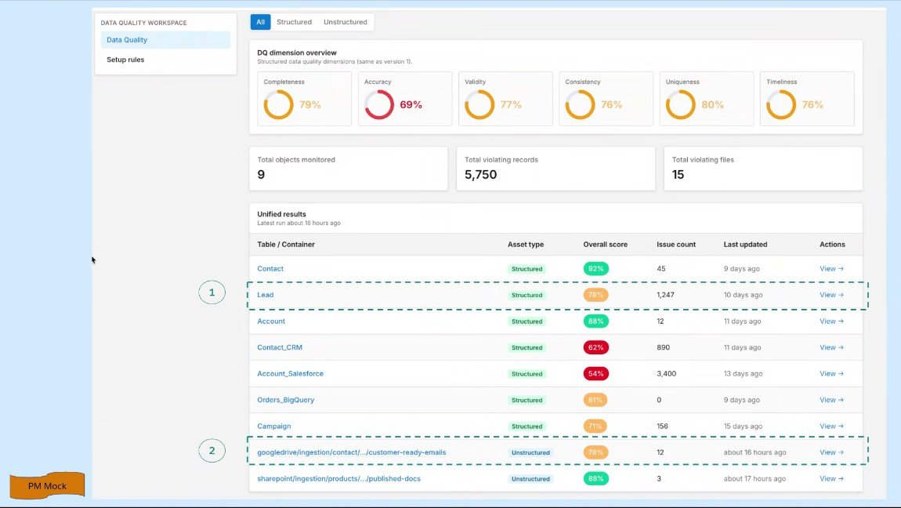
- Salesforce Footprint and Existing Implementations: Chris Phillips and Ricardo Sobral provided background on Informatica's footprint with existing Salesforce implementations, noting that Salesforce CRM was historically a major focus when IDMC started, and efforts are now being ramped up again (00:12:16). Currently, 67 accounts are scanning Salesforce CRM metadata through the governance and catalog suite, though it is unclear how many of those are actively performing data quality evaluations (00:13:35). They detailed that customers utilize data quality in several ways, including through governance/catalog, by building custom reporting frameworks via APIs, and through integration with Master Data Management (MDM) (00:14:43).
- Customer Zero Initiative and Data Quality: The team confirmed engagement with the Salesforce Customer Zero initiative, where Salesforce uses its own products. It was noted that while they are engaged from all aspects, including data quality, they are not far along with the DQ front within the Customer Zero workstream. Chandrika Shankarnarayan confirmed they are plugged into the workstream, but more collaboration is needed to connect the dots between Customer Zero, Informatica, and their internal work (00:18:35).
- Data Quality Metrics and Data Cloud: The DQ metrics will be run against Data Cloud DMOS and DLOS, where the data quality score has already been run. The Informatica team is launching data quality on Data 360 DMOS by April, which was why this was considered a feasible path (00:19:35). The Informatica team is pulling Data 360 metadata for DMO/DLO information and scanning it to perform cataloging, lineage tracking, and DQ analysis (00:20:35).
- Informatica Connectivity and Data Handling: Informatica is transitioning from using a generic JDBC connector to a native IDMC connector for Data 360 in April, which means Informatica will own the complete code and support (00:22:28). When running DQ, the data itself is not moved to Informatica; instead, an agent connects to Data 360, reads the data, calculates the profiling and rule results, and stores only the results in IDMC (00:41:39). The initial primary use case focuses on displaying these DQ results within Data 360, targeting the analyst persona (00:22:28).
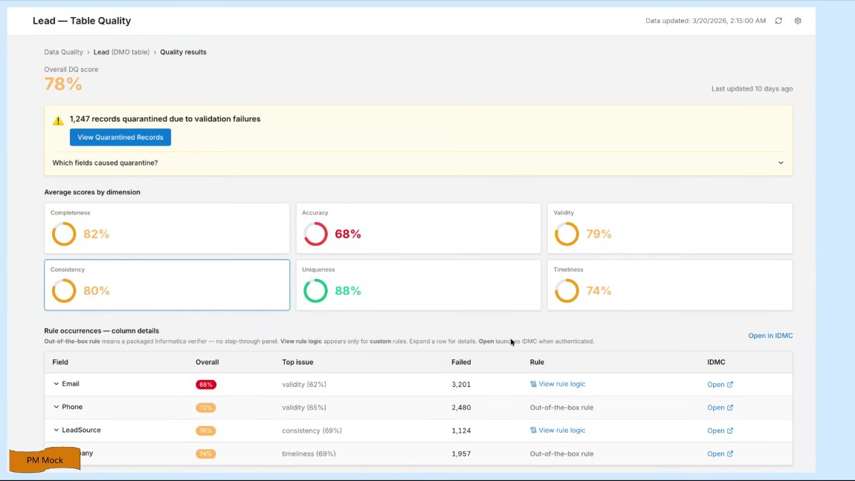
- Data Quality Pattern and Custom Reporting: Informatica supports two primary patterns for accessing DQ results: using their own UIs or utilizing APIs to pull data into external reporting tools like Tableau or PowerBI. The proposal to pull scores from IDMC into Data 360 is similar to an integration done previously with Microsoft Fabric, which involved a one-way pull of information (00:25:57). Chris Phillips inquired about the volume of Data 360 customers to understand the scale of the integration (00:28:05).
- Data Quality Automation and Metrics Storage: To reduce friction, the goal is to make the process as simple as an on/off switch for the end user. Currently, DQ scores are stored at individual levels (e.g., score for email completeness on a specific date), which requires aggregations to surface metrics like lead completeness (00:29:28). The more known entity for storing and retrieving scores is through the Cloud Data Governance and Catalog (CDGC) pieces, which provides standard APIs and a known scoring model (00:17:23).
- Data Quality Deliverables in April Release: The April release will include two deliverables: the scanner deliverable, which is read-only and pulls metadata for cataloging and profiling, and the native connector, which supports read-write operations via mappings (00:38:06). Data profiling, which involves calculating machine statistics like null counts and distinct counts, is part of the scanning operation (00:34:35). Furthermore, Daksha Asrani confirmed that the scenario where Informatica reads a DMO, runs DQ rules, stores the results in IDMC, and then writes cleansed records back to Data 360 is technically possible (00:46:11) (00:51:29).
- Headless Data 360 and Future Direction: Headless Data 360 is being announced at TDX, with an aggressive internal push to integrate agent-driven conversational experiences (00:54:09). Chandrika Shankarnarayan stated that the "better together" narrative must evolve to serve the customer in their flow of work, whether they are a human or an agent, by providing DQ capabilities where they are, including Data 360 or via headless methods (00:55:35). Brian Bolger noted concerns about the time frames and the current setup for agentic and headless expectations (00:57:37).
- Discussion of Headless Integration and Cloud Code: The conversation began by noting that Adita's team is working on headless integration, which was announced at TDX. The main driver for this headless case is identified as the cloud code or cloud itself, requiring minimal setup on the Data Cloud (DC) side, primarily establishing the connection. The goal of headless integration is for the cloud to coordinate tasks, such as finding data objects and directing Informatica to perform data quality (DQ) checks (00:58:46).
- Mechanism of Data Quality Rule Reflection and API Calls: The discussion covered the necessary work for headless integration, which involves writing "skills" to facilitate communication between systems. Chandrika Shankarnarayan suggested that the rules should reflect quality results in Data 360, and this process involves back-and-forth API calls through the headless mechanism to update experiences. Ahmet Akkas confirmed that an agent is responsible for stitching together these components, such as retrieving data quality needs from Data Lake (DL) and coordinating with Informatica, including figuring out tenancy (00:59:49).
- Differentiating Headless Architecture from Federation and Ingestion Models: Ahmet Akkas clarified that the headless approach differs from previous models discussed at the last tech summit, which included catalog federation or data ingestion into their system (01:00:57). The headless model involves a third-party agent, much like a user, who interacts with APIs from both systems (Data Cloud and Informatica) to retrieve and stitch together data sets. This third-party agent capability is what the cloud is making faster and context-aware (01:02:24).
- Comparison of Two-Way Integration and Better Together DQ Story: Chris Phillips emphasized that the current discussion leans toward a two-way integration, which requires more definition, unlike single-direction integrations with providers like Snowflake or Databricks. Ahmet Akkas introduced the "better together" DQ story, stating that it should be active and serve as a gate to prevent corrupted or substandard data quality from progressing through the ingestion, mapping, transformation, and segmentation pipelines (01:04:44). They stressed the necessity of viewing the DQ story holistically beyond merely displaying stitched data (01:06:05).
- Need for Faster Progression Towards Headless Work: Chandrika Shankarnarayan agreed that the DQ story requires more than simple display and that the recent progress on headless integration necessitates faster progression toward this work, rather than focusing solely on previous DQ surfacing plans. Ahmet Akkas acknowledged they could start immediately, but stressed the importance of understanding the APIs involved and what work is being done for headless integration (01:07:09). The expectation is that once the generic headless framework is established, DQ will follow, potentially with minimal effort (01:08:18).
- Request for Proactive Information on Skills and Cloud Requirements: Brian Bolger requested that someone proactively send information regarding the skills and cloud requirements, noting that their team has "no line of sight" on what they will be asked to do to support these skills. They emphasized the need to ensure capabilities exist or to flag back where they do not, to set appropriate expectations. Chandrika Shankarnarayan explained that the headless push is moving quickly and is being directed by top leadership (01:10:45).
- Challenge of Rapid Directives and Existing Development Plans: Ricardo Sobral noted that the new directives from leadership are not currently reflected in the existing October plan, requiring a plan change. Brian Bolger requested that as information becomes available, they should be informed so they can assess how far away they are from readiness, stating that they will be servicing the detailed requirements (01:12:27). Chandrika Shankarnarayan assured them they are also receiving input quickly and will share information, acknowledging that the ground reality might mean they are not ready (01:13:15).
- Exploring Headless Development while Maintaining Current Plans: Ricardo Sobral asked if the current work, such as bringing data to Data 360, should be paused to focus solely on headless integration. Chandrika Shankarnarayan responded that they are not confident enough to abandon the current work entirely since Informatica may not be ready for headless integration (01:13:54). Instead, they suggested that the group should start exploring the headless path and "keep their ears to the ground" to prepare for it, while continuing to hold on the current direction (01:14:33).

You should review Gemini's notes to make sure they're accurate. Get tips and learn how Gemini takes notes
How is the quality of these specific notes? Take a short survey to let us know your feedback, including how helpful the notes were for your needs.

